DELHI TECHNOLOGICAL UNIVERSITY



STOCHASTIC PROCESSES

(MC-303)

PRACTICAL FILE

SUBMITTED TO:

PROF. H C TANEJA

MR. VINEET KUMAR

SUBMITTED BY:

NITYA MITTAL

(2K19/MC/089)

EXPERIMENT 9

# AIM

Demonstrating Markov Chain (Cont.) WAP to implement following special cases in case of a Markov Chain

(a) To find steady state probabilities in case of ergodic Markov Chain.

(b) To find that the specific state in a Markov chain is a recurrent or transient.

# THEORY

A Markov chain is a mathematical system that experiences transitions from one state to another according to certain probabilistic rules. The defining characteristic of a Markov chain is that no matter how the process arrived at its present state, the possible future states are fixed. In other words, the probability of transitioning to any particular state is dependent solely on the current state and time elapsed. The state space, or set of all possible states, can be anything: letters, numbers, weather conditions, baseball scores, or stock performances.

Markov chains may be modeled by finite state machines, and random walks provide a prolific example of their usefulness in mathematics. They arise broadly in statistical and information-theoretical contexts and are widely employed in economics, game theory, queueing (communication) theory, genetics, and finance. While it is possible to discuss Markov chains with any size of state space, the initial theory and most applications are focused on cases with a finite (or countably infinite) number of states.

## SOURCE CODE

i)

function [ answer ] = ergodic(tpm,n)

tpm = -tpm;

for i=1:n

for j=1:n

if i == j

tpm(i,j) = 1;

end

end

end

A = [tpm';ones(1,n)];

B = zeros(n+1,1);

B(n+1) = 1;

answer = linsolve(A,B);

end

## OUTPUT

i)

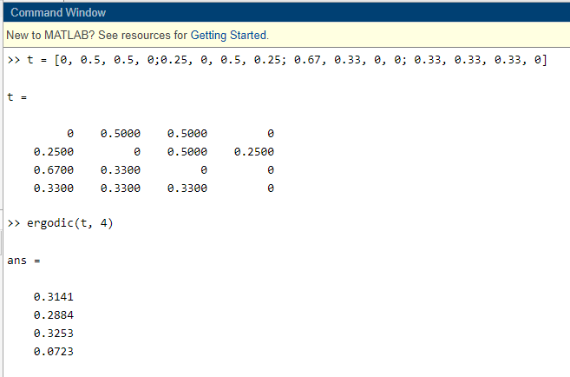

ii)

